**Opening question to be read:**

**What are the indications for arterial cannulation?**

**Measurement**

continuous BP monitoring

CO monitoring

ABG analysis

Repeated blood sampling e.g serial clotting studies during haemorrgage.

**Diagnostic**

Angiography

**Therapeutic**

Thrombolysis

Stenting

EVAR

RRT

ECMO

Vasodilator chemotherapy

**b) Specifically for BP monitoring, give clinical indications?**

Obese patient

When transferring patients.

Tachyarrthmias e.g AF

During surgeries when BP may change rapidly e.g Cardiac operations

When using Inotrope infusions.

Burns patients - if NIBP would not be possible

Porlonged surgery - to prevent risk of neuropraxia.

**How Does Invasive BP measurement work?**

cannula, (20g - short, stiff) inserted into peripheral artery.

connected to a transducer via column of pressurised saline ( short, wide and stiff tubing)

Pressure of saline typically >300mmHG (above Systolic BP)

transducer at level of patients heart.

continuous flow of approx 4mls/hr of saline through cannula and transducer set to prevent occlusion.

The pressure from artery is transmitted through fluid column to a thin diaphragm.

The movement of diaphragm, caused by arterial pressure, is detected by strain gauge. The wires in the transducer are stretched and their electrical resistance changes

Resistance signal is converted to a pressure signal by calibration.

a wheatstone bridge in incorporated into the system to make this more accurate.

Signal from the transducer is then amplified and displayed as a continuous waveform

**How does the form of the pressure wave change according to choice of artery?**

Wave becomes narrower and increase in amplitude in more peripheral arteries. therefore systolic BP in dorsalis pedias artery is higher than radial artery etc.

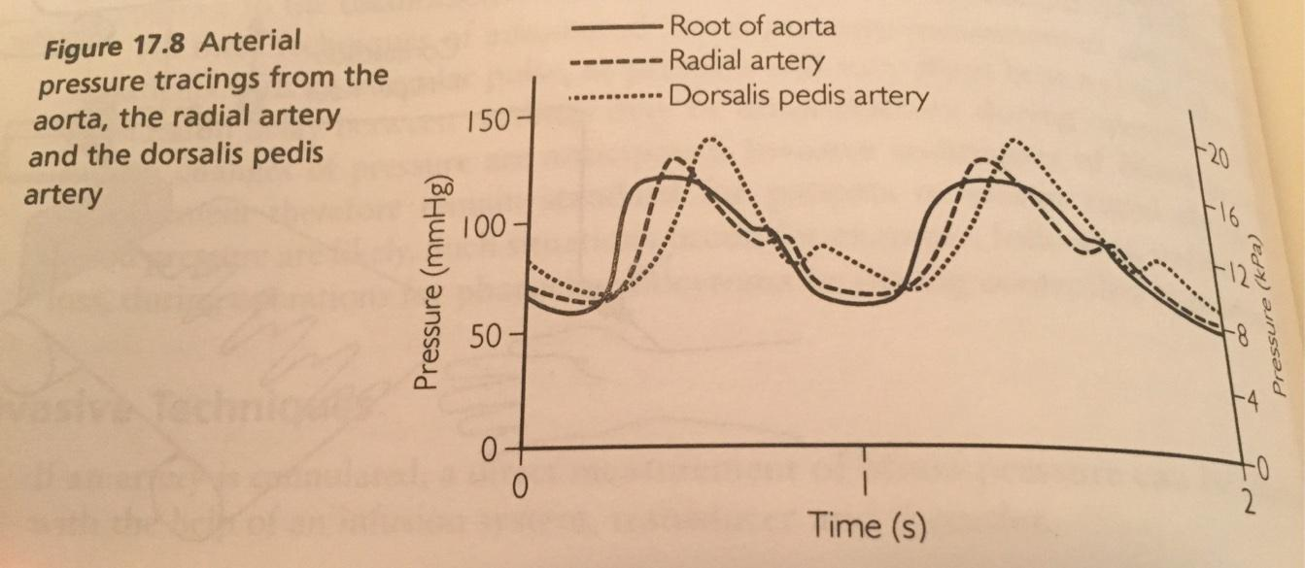

**Outline the sources of error when measuring invasive arterial pressure?**

1. Wrong position of transducer - Therefore ensure it is levelled with atrium
2. Causes of Damping - any restriction to the transmission of blood pressure from artery to diaphragm i.e Air Bubbles, Blood Clots, vasospasm, kinking of cannula
3. Causes of Resonance - presence of 3 way taps, long catheter length, narrow radius, flexible catheter)
4. Transducer Drift - therefore zero transducer frequently
5. Monitor not calibrated
6. Pressure of flushing system <300mmHG

Maximal heart rates a monitor might encounter are approx.240bpm ( neonate or adult SVT) which equates to 4Hz and is know as the fundamental frequency. Most commercial IABP measuring systems have a natural oscillating frequency of around 200Hz this makes Resonance less likely However this is reduced by the addition of three-way taps, bubbles, clots and additional lengths of tubing

**What is damping?**

The ability of a system to resist oscillations. Anything that reduces energy in an oscillating system will cause damping.

Some degree of damping is required in all systems (critical damping), but if excessive (overdamping) or insufficient (underdamping) the output will be adversely effected.

**How can a fast flush or ‘Square wave’ flush Test be used to demonstrate the damping present in an arterial line system?**

Short flush of transducer set with pressurised saline.

If Wave returns to baseline without any Overshoot = **Critically Damped system:** Damping Co-effiecent =1. This is too slow in practice.

If the frictional forces in the system are not enough to stop it overshooting the zero point - the system is said to **under -damped.** Damping-coeffient is less than 1. The monitor will exaggerate signals and falsely higher readings.

**Over- damped** system will not overshoot the zero point because the frictional forces are sufficient but the time taken to reach zero is too long. Damping coefficient >1. Waveform amplitude is flattened and Diatolic articulacy High and systolic artificially Low

**Optimal damping : a compromise between amount of overshoot (accuracy) and response speed and this occurs with Damping coefficient of 0.64. The monitor will overshoot once in each direction before settling back into sine waveform.**

